DIGITAL MARKETING

Assignment 2 – Creating a facebook page and posting a social media poster



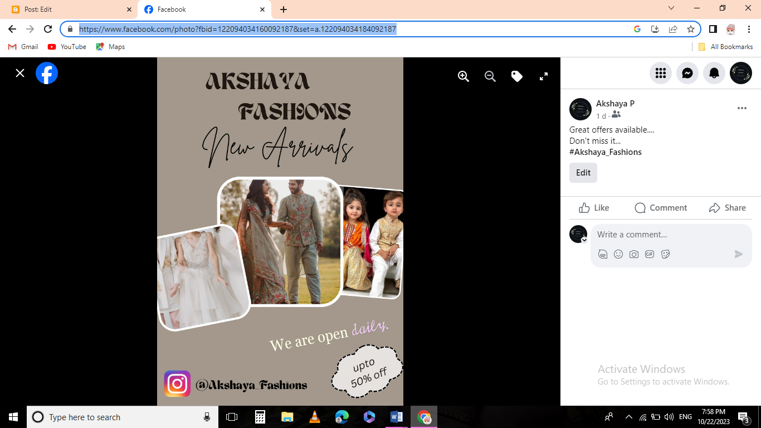Figure: facebook profile

Figure: Social media poster

Facebook post link:

<https://www.facebook.com/photo?fbid=122094034160092187&set=a.122094034184092187>

wSocial media poster of a clothing brand: